# CS 255 System Design Document Template

## Robert Sanford

2022 SNHU

## UML Diagrams

### UML Use Case Diagram

### UML Activity Diagrams

User login and package purchase

### UML Sequence Diagram

User Login

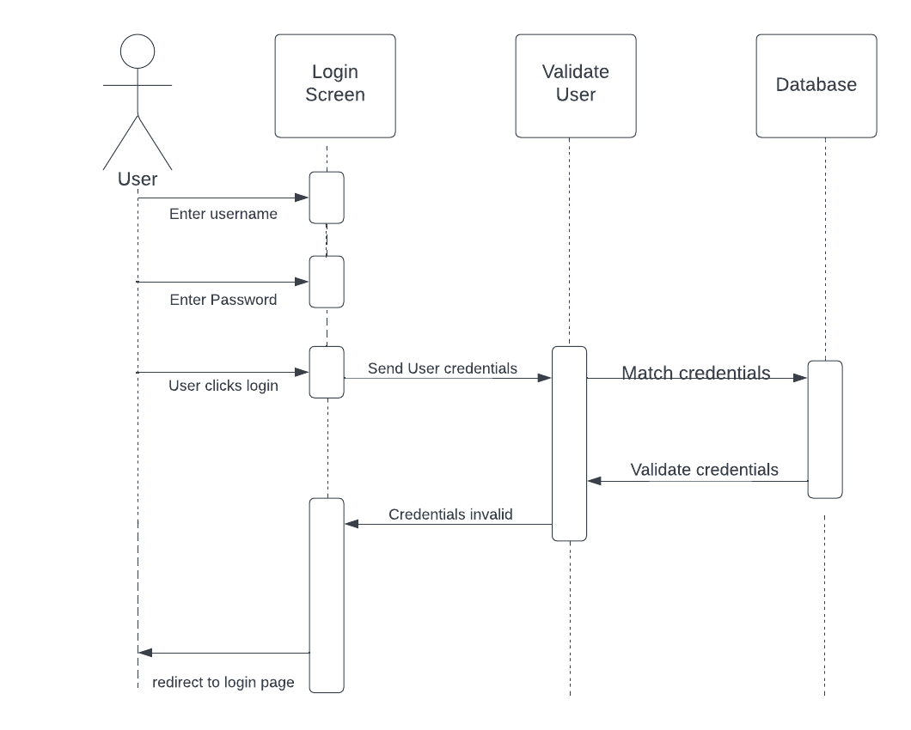

### UML Class Diagram

## Technical Requirements

The DriverPass System has several technical requirements. The system will be web-based and hosted on the cloud. The system will havea database to store usernames and passwords along with study materials. Access to the system will be based on roles such as admin and customer. The system will also need to encrypt data being sent over the cloud, preferably using SSL protocol, for security. The system will also need to connect to the DMV’s database in order to stay up to date on driving regulations.